PODIATRIC SURGERY INFORMATION GUIDE:
HALLUX LIMITUS / RIGIDUS

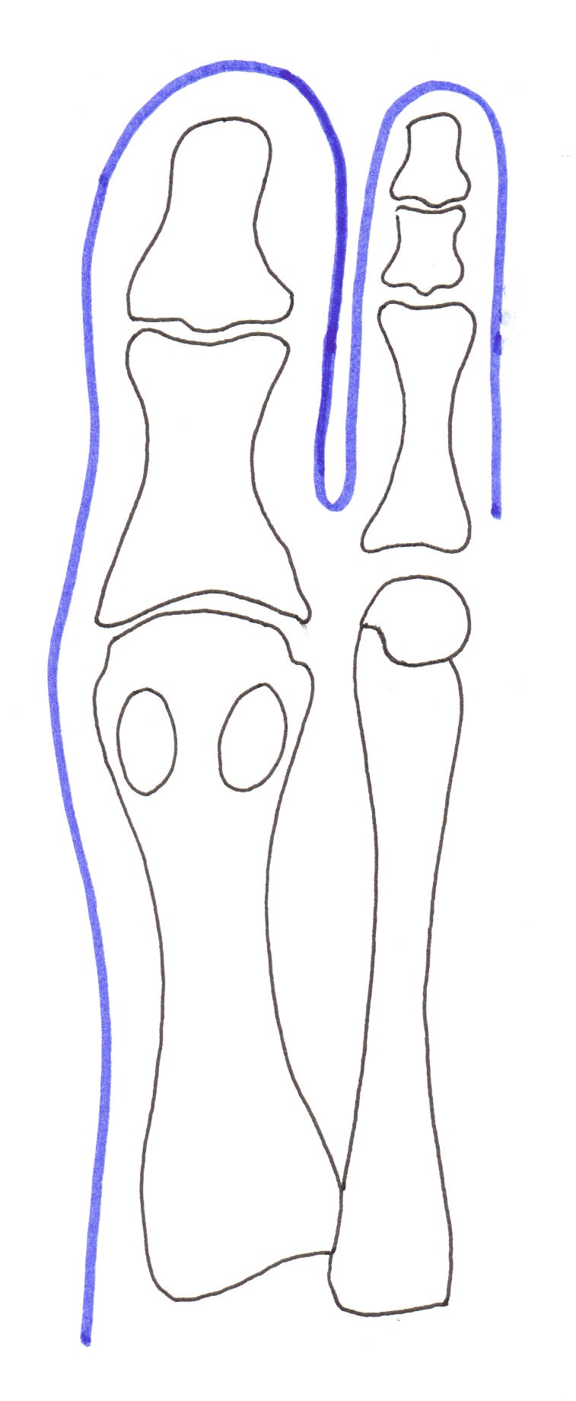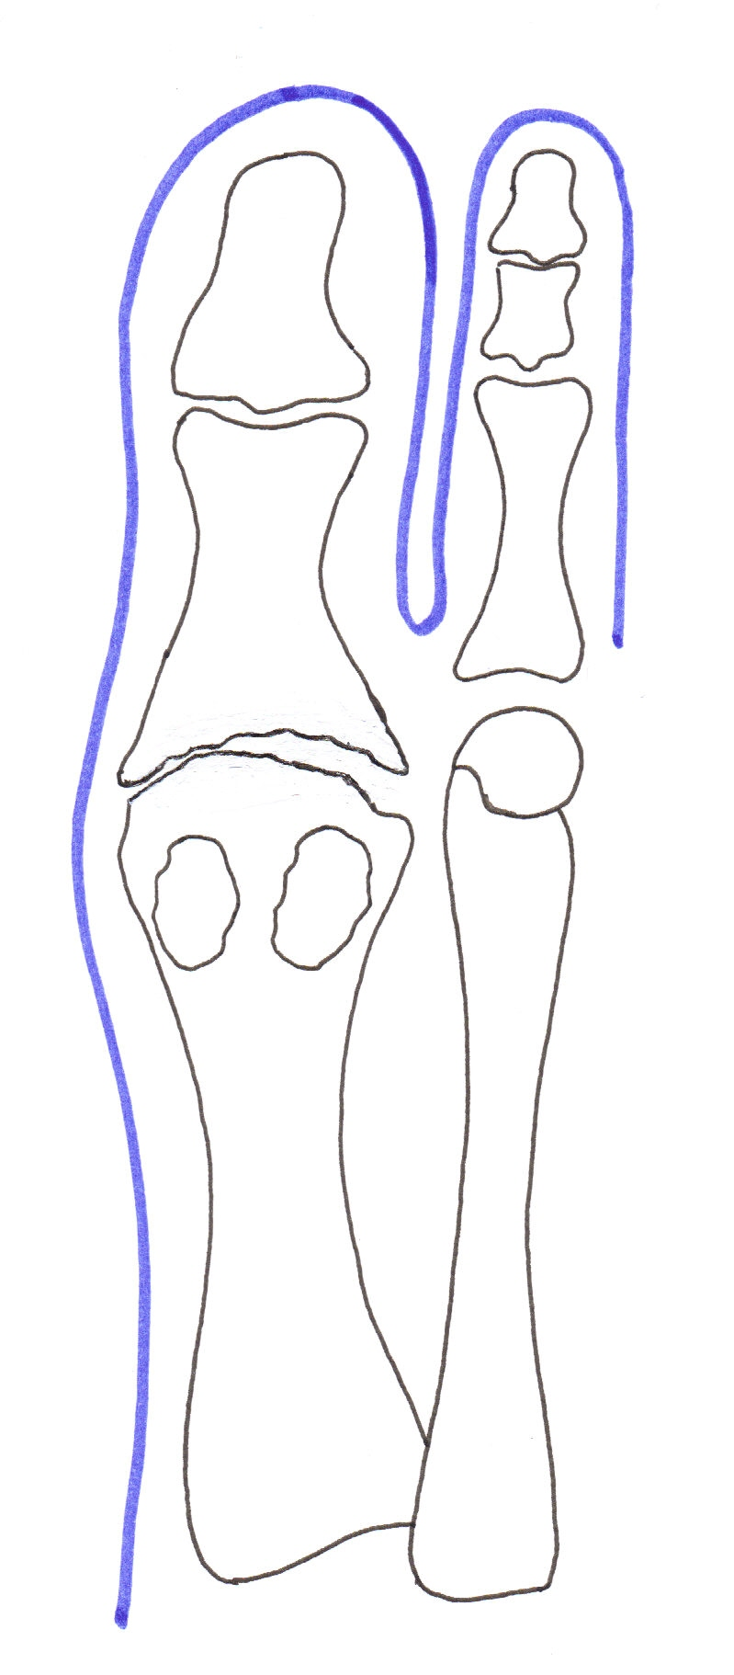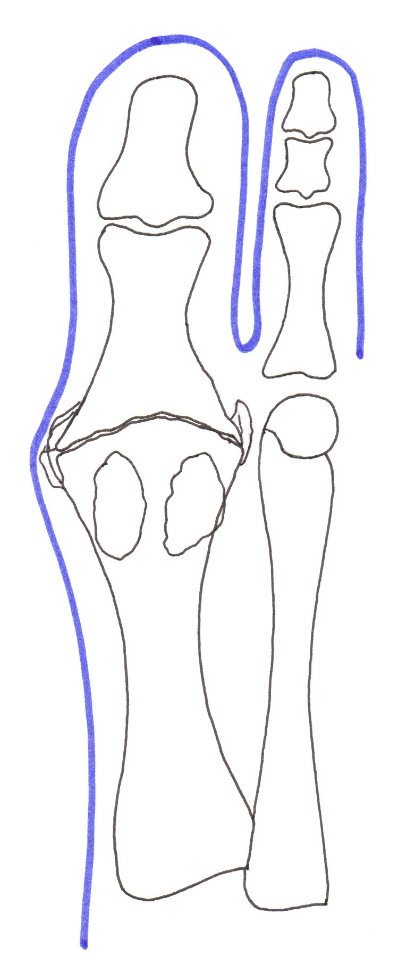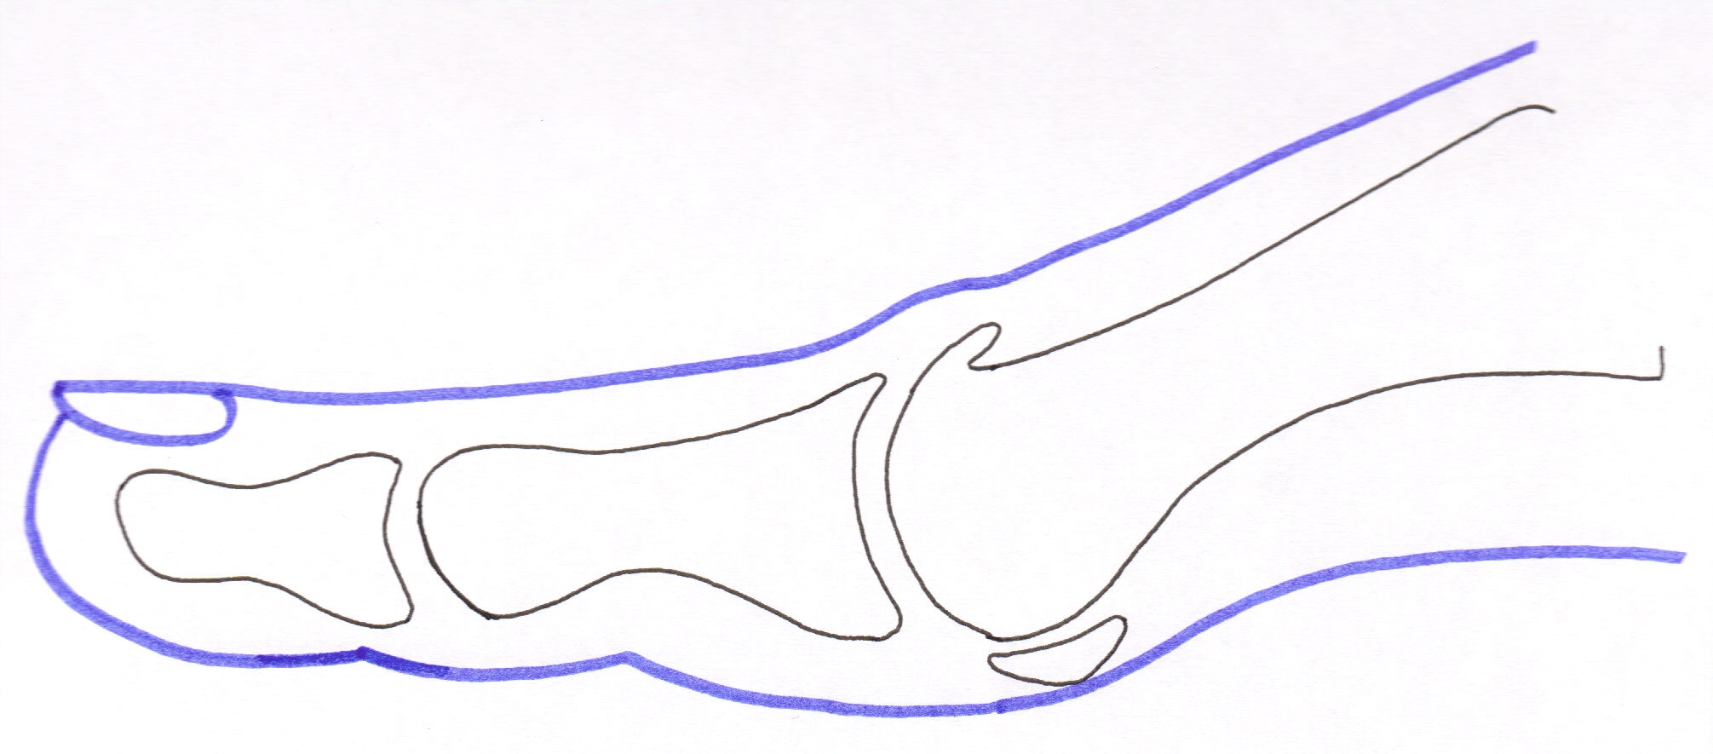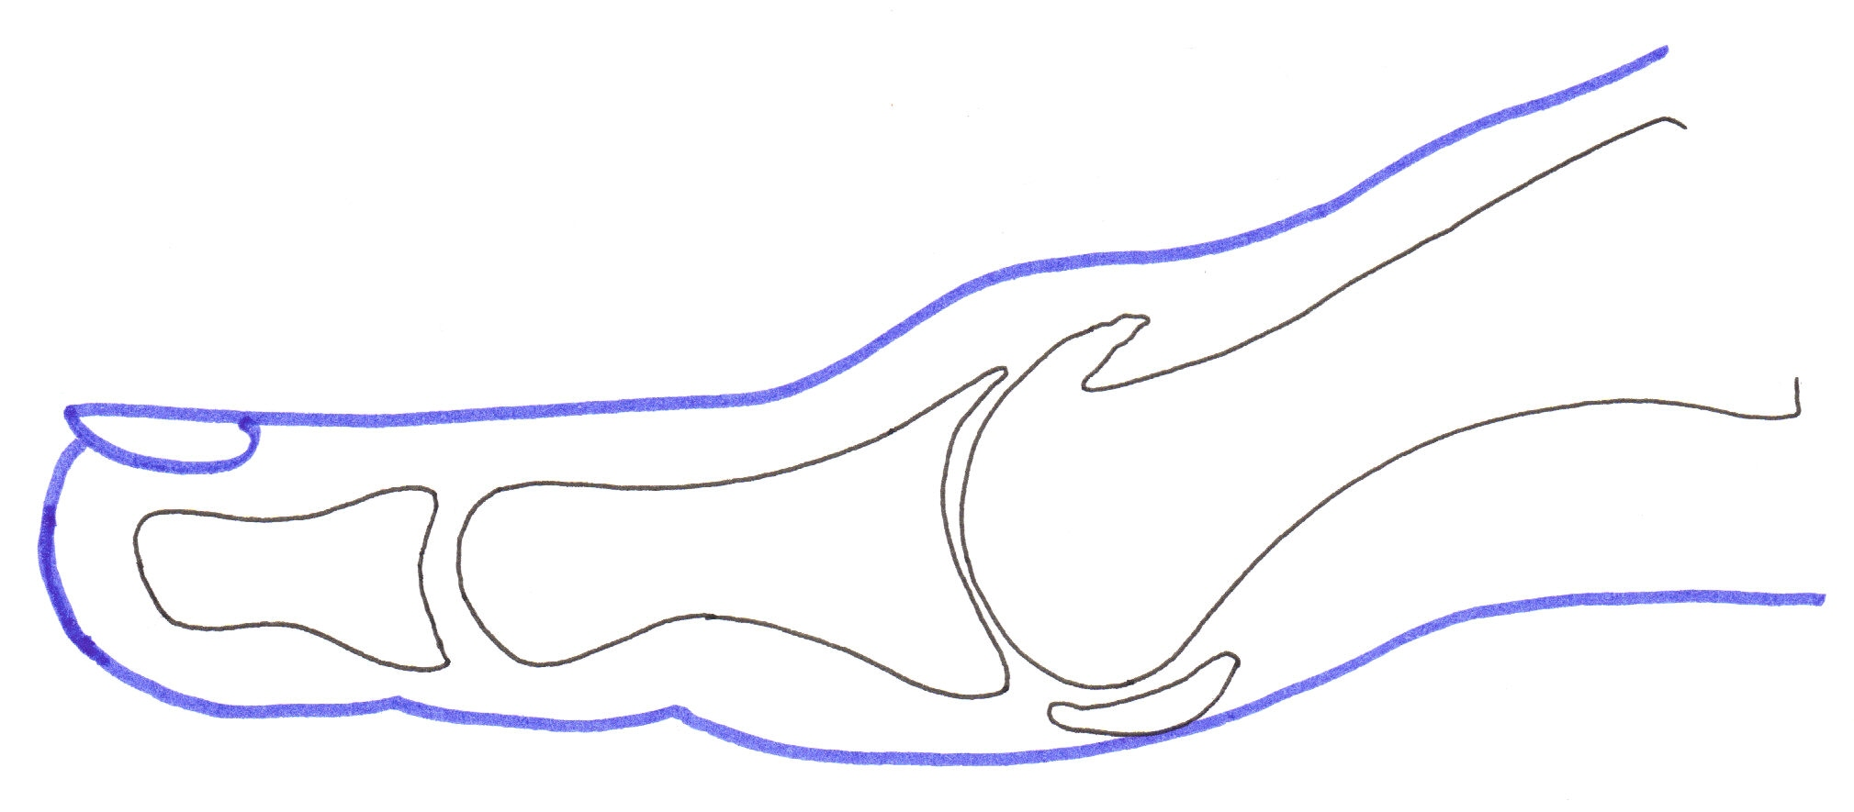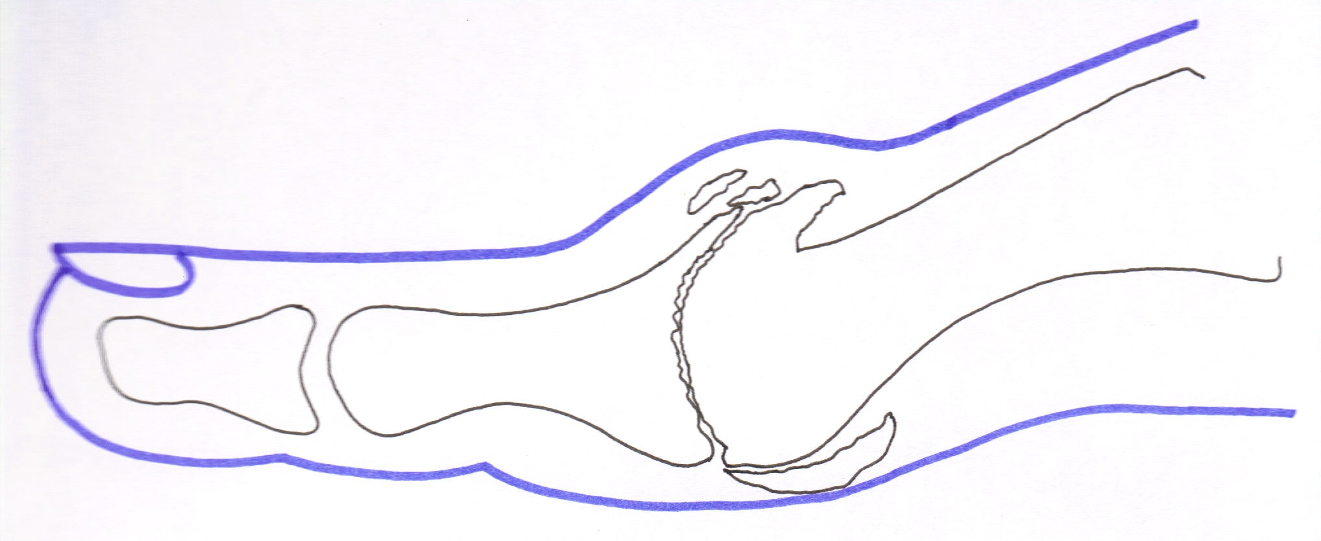

Grade 1 (Mild) Grade 2 (Moderate) Grade 3 (Severe)
(Hattrup and Johnson scale)

What is hallux limitus/rigidus?
- Stiffening of the big toe joint movement, known as hallux limitus, is a common foot condition. Movement may become reduced to the point where there is minimal or no joint movement, known as hallux rigidus.
- The limitation of joint movement is due to osteo arthritis affecting the joint.
- Osteo arthritis is a progressive condition and gradually wears away the joint cartilage causing bone to grind against bone. This causes joint pain.
- Extra bone forms around the joint in an attempt to stop this painful movement.
- This bump may rub on shoes, and in some people this is their only problem.
- Pain may also be experienced under the second toe ‘knuckle’ joint or outer side of the foot because the big toe is not functioning properly affecting the way we walk.
- The big toe may deviate toward the smaller toes causing crowding and further irritation.

What causes hallux limitus/rigidus?
- Injury to the joint is the commonest cause. This can be due to one major event or repeated trauma.
- Abnormal joint wear and stiffening are also associated with joint diseases such as rheumatoid arthritis and gout.
- Abnormal foot function during walking can overload the big toe joint causing hallux limitus /rigidus formation.
- Tight narrow fitting shoes with increased heel height place increased pressure on the big toe joint, predisposing to abnormal wear and tear.
- Infection within the joint.

TREATMENT OPTIONS:

- This condition generally gets worse with time, although the rate of deterioration is difficult to predict and varies from person to person.
- Depending upon the degree of pain, extent of joint damage (grade), and deviation of your big toe, there are several options:

Non- surgical treatments
- Protective pads.
- Avoid tight or high heeled footwear.
- Wear stiff rocker soled shoes. These reduce stress on the joint.
- Avoid activities that knowingly irritate the joint.
- Exercises to keep the joint mobile / or splinting to limit movement.
- Pain killers / anti-inflammatory medications and gels.
- Dietary supplements such as Glucosamine and Chondroitin may help reduce pain.
- Insoles (orthoses) aimed at improving foot function and reducing stress through the joint.
- Anti-inflammatory gels and pain killers
- Cortisone or Hyaluronic acid injections into the joint.

Surgical intervention
- Sadly, no surgery can undo the damage that has already occurred and return the joint to normal.
- The aim is to preserve the joint where possible, however in severe cases where the joint is too damaged to be preserved, procedures that destroy the joint are recommended.
- Generally, joint preserving operations are offered for Grades 1 and 2; joint destructive for grade 3 (see diagrams on page 1), although other factors such as your lifestyle, expectations and age are important factors too.
- Sometimes despite thorough examination, the final decision on most appropriate procedure can only be made by assessing the joint during the operation.
- Joint preserving operations: These should be considered a ‘stopgap’, with the possibility of further surgery being required in the future.
  - Cheilectomy
    - This is the removing of the prominent bony bumps on the top of the joint and the joint ‘washed out’.
    - This often relieves discomfort from shoe irritation and may increase joint movement, although studies have shown many joints are stiff but not necessarily painful again after 2 years.

  - Sesamoidectomy
    - The two sesamoid bones underneath the metatarsal head often become arthritic and fused to the metatarsal, contributing to reduced joint motion.
    - Removing the sesamoid bones can help to restore joint motion.

  - Kessel-Bonney Osteotomy
    - This operation involves undertaking a cheilectomy then removing a small wedge of bone from the base of the big toe bone.
    - This aims to decompress the joint and lifts the big toe off the ground to make the most of the joint movement that is present.

  - Decompressive Metatarsal Osteotomy
    - If the first metatarsal is too long it can cause the big toe joint to jam when walking.
    - This operation involves shorting the metatarsal to within normal limits aiming to allow the joint to function more normally again.
    - This is often combined with a cheilectomy.

Joint destructive operations:
  - Joint Fusion
    - This operation is performed where there is severe, painful arthritis and joint movement is minimal.
    - The painful joint surfaces are removed and the bones fixed together (termed an ‘arthrodesis’) by placing screws and /or a
plate across the joint.
    - You will be immobilised in a case for 6 weeks to allow the bones to fuse.
    - After surgery the big toe will be a little shorter and will no longer bend.

    - 95% of patients have big toe joint pain eased; however the toe is fused in a slightly elevated position to facilitate walking, which will affect the heel height of the shoe you can wear.
    - Fusion also alters the way in which you walk, transferring pressure onto the outside of the foot which may cause discomfort.
    - Often this operation is recommended for younger active patients due to

  - Joint replacement (implant)
    - In middle aged, moderately active people this is an option.
    - The arthritic joint is replaced with a moveable silicone joint and has the advantage of maintaining the toe length.
    - The implant wears out after an average of 10 years, so further surgery may be required if pain reoccurs.

  - Keller’s arthroplasty
    - This involves a joint cheilectomy and removing the arthritic base of the big toe bone.
    - This is effective at improving joint pain but leaves the toe shortened and weaker which may cause pain to develop on the ball of the foot.
    - For this reason, this is recommended for the elderly, less active, or in whom healing and recovery may be an issue.

Intended benefits of an operation
The aim of an operation is to improve comfort of the big toe joint and remove prominent bony bumps.

If you are considering surgery, please be aware we do not advise patients to undertake air travel until at least 6 weeks post surgery.

You should be aware that these complications are relatively uncommon. They mostly resolve without permanent disability or pain using medications, therapy and on occasions further surgery, but even allowing for these, sometimes you may not achieve the result that you want.

We do NOT advise surgery purely for cosmetic reasons. We also advise against prophylactic surgery (which is preventative surgery to avoid problems that are not yet present).

